**Software Requirements and Design Document**

**For**

**Group 2**

Version 2.0

**Authors**:

Zachary Ortiz

Joe Sahl

Rafe Ewert

# Overview (5 points)

The game is a recreation of Super Mario Bros from the NES, and is being built in Godot, a game engine that supports 2D platformers. It is being written in Godot’s own language, GDScript. The game will have three levels: Overworld, Underground, and Castle. Each level will have its respective difficulties due to certain elements, such as enemy count, obstacle count, and item count. (Z)

# Functional Requirements (10 points)

1. Player must have control over Mario, so that based upon key input, he reacts accordingly (High) (Z)
2. Player must be able to start and quit the game on a title menu (High) (Z)
3. Mario must have proper collision and behavior with enemies, items, and obstacles (High) (Z)
4. Enemies must have behavior and be able to be killed by Mario. (High) (J)
5. Enemies must add to score and be able to damage or kill Mario. (High) (J)
6. Bowser must have different behavior and act as a “final boss” for the last level. (High) (J)

# Non-functional Requirements (10 points)

1. The behavior of Mario must carry across the levels (Z)
2. The game must run decently, i.e. no serious frame drops (Z)
3. Game should be able to be paused, stopped, and restarted every time a player loses or quits (R)
4. Game should closely resemble the original Super Mario Bros (J)

# Use Case Diagram (10 points)

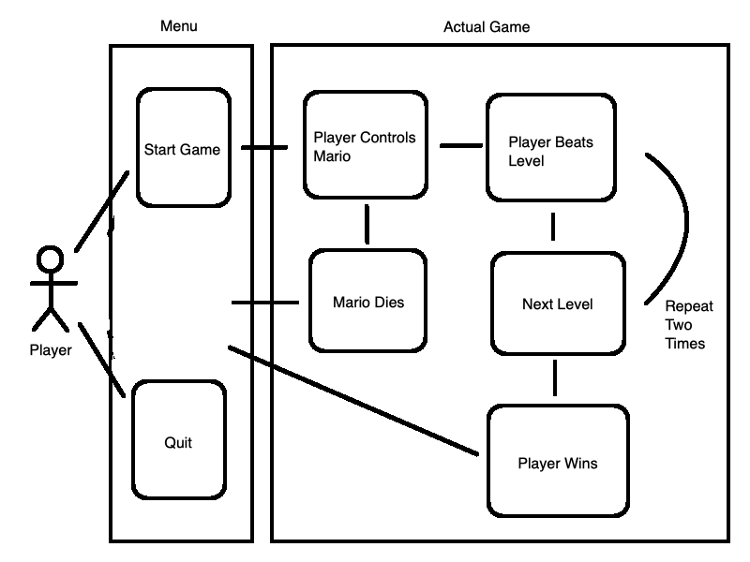

Use Case Name: Playing the Game

Actors: Player

Preconditions: Player downloads and starts the game

Normal Flow: Player clicks “Start Game” and takes control of Mario before playing through three levels and winning the game, to which they’ll then be booted back to the main menu

Alternative Flows: Player clicks “Quit” and the game closes, or Mario dies while going through a level, and upon all lives being used up, the Player is shown a “Game Over” screen before being booted back to the main menu

# Class Diagram and/or Sequence Diagrams (15 points)

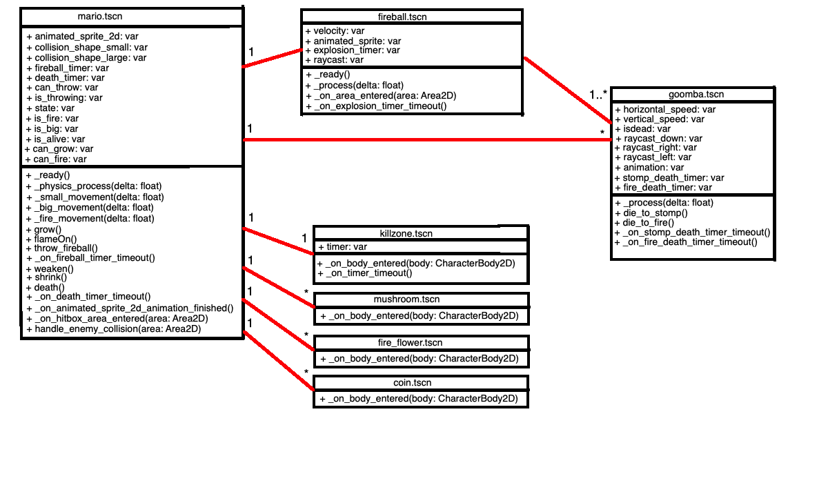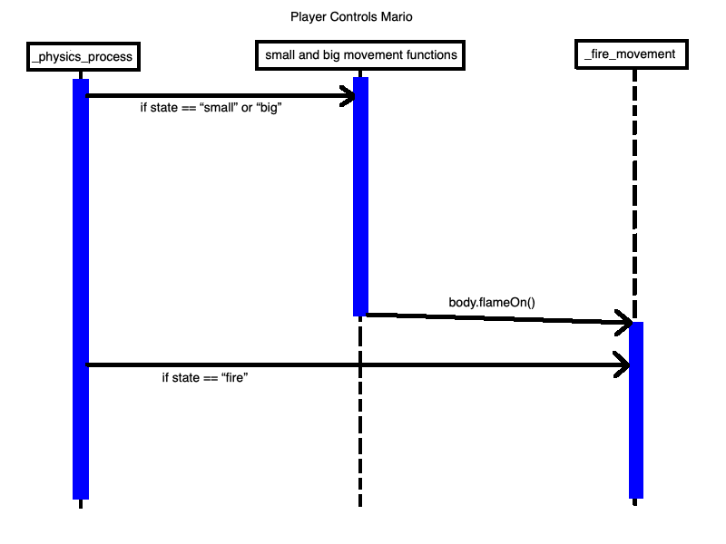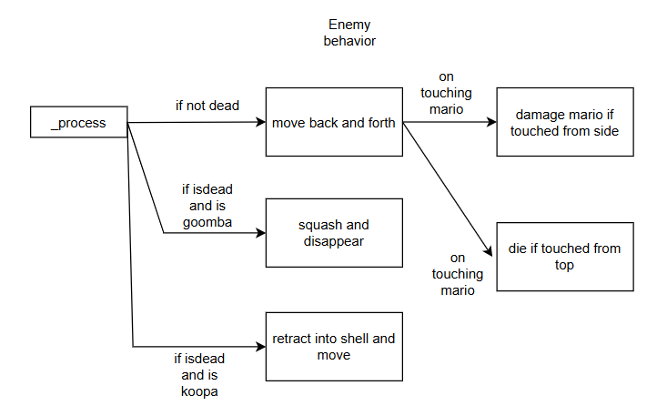

# Operating Environment (5 points)

The game will be playable on any kind of computer, be it desktop, laptop, Windows, or Mac. It will not run on any other kind of platform. (Z)

# Assumptions and Dependencies (5 points)

There are no dependencies on other projects, and it is the assumption that the system, or game, will be downloadable from Github and playable that way. (Z)

We also assume the user has enough technical knowledge to download and install a game from GitHub. (J)

This project assumes that the user will be playing on Windows or Mac, not necessarily on consoles or Linux. (R)